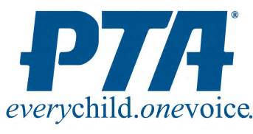
LEOTA PTSA
MEMBER DISCOUNTS
Washington State PTA members can save money through member benefit providers. WSPTA collaborates with businesses and associations that support WSPTA’s mission and vision. As part of that relationship, these organizations offer members special discounts.
- Avis Car Rental
- Budget Car Rental
- FedEx Office
- Great Wolf Lodge
- Hertz Car Rental
- Key Arena/McCaw Hall

- Movie Licensing USA
- Silverwood Theme Park
- Tacoma Dome
- Ticket Monster Perks
- Washington State Fair
- Xfinity Arena at Everett
- Le-May – America’s Car Museum

To find out more about these benefits, please visit: http://www.wastatepta.org/member/value_benefit/value_benefit.html

